**Assignment 2**

**COMP 1002**

1. Design a simple application using JavaScript and HTML. It should perform the following action. **(15 marks)**
2. Create a four button with values Red Rose, White Rose, Blue Rose and Pink Rose.
3. With the help of different images, you can perform this action and use appropriate code of the javascript.
4. In this case JavaScript changes the src (source) attribute of an image.
5. Take images from the folder PROG_1800 with the name of the images is red_rose, white_rose, blue_rose and pink rose.
6. When will you change the image text will also change e.g. “Red Rose”,”White Rose” etc.
7. By default, the flower should be red rose.

Screenshot of the application are given below:

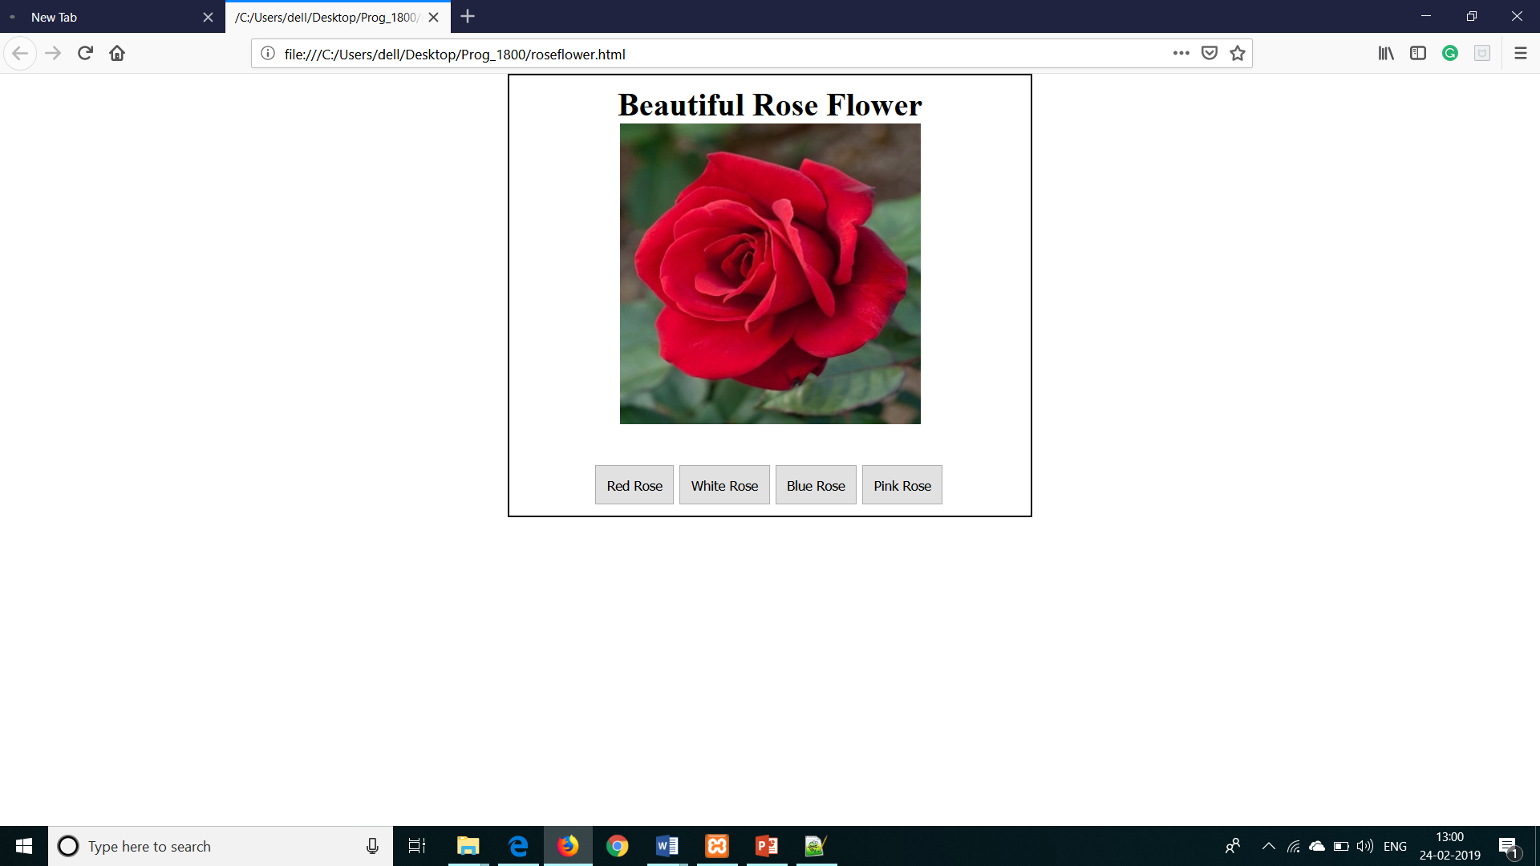 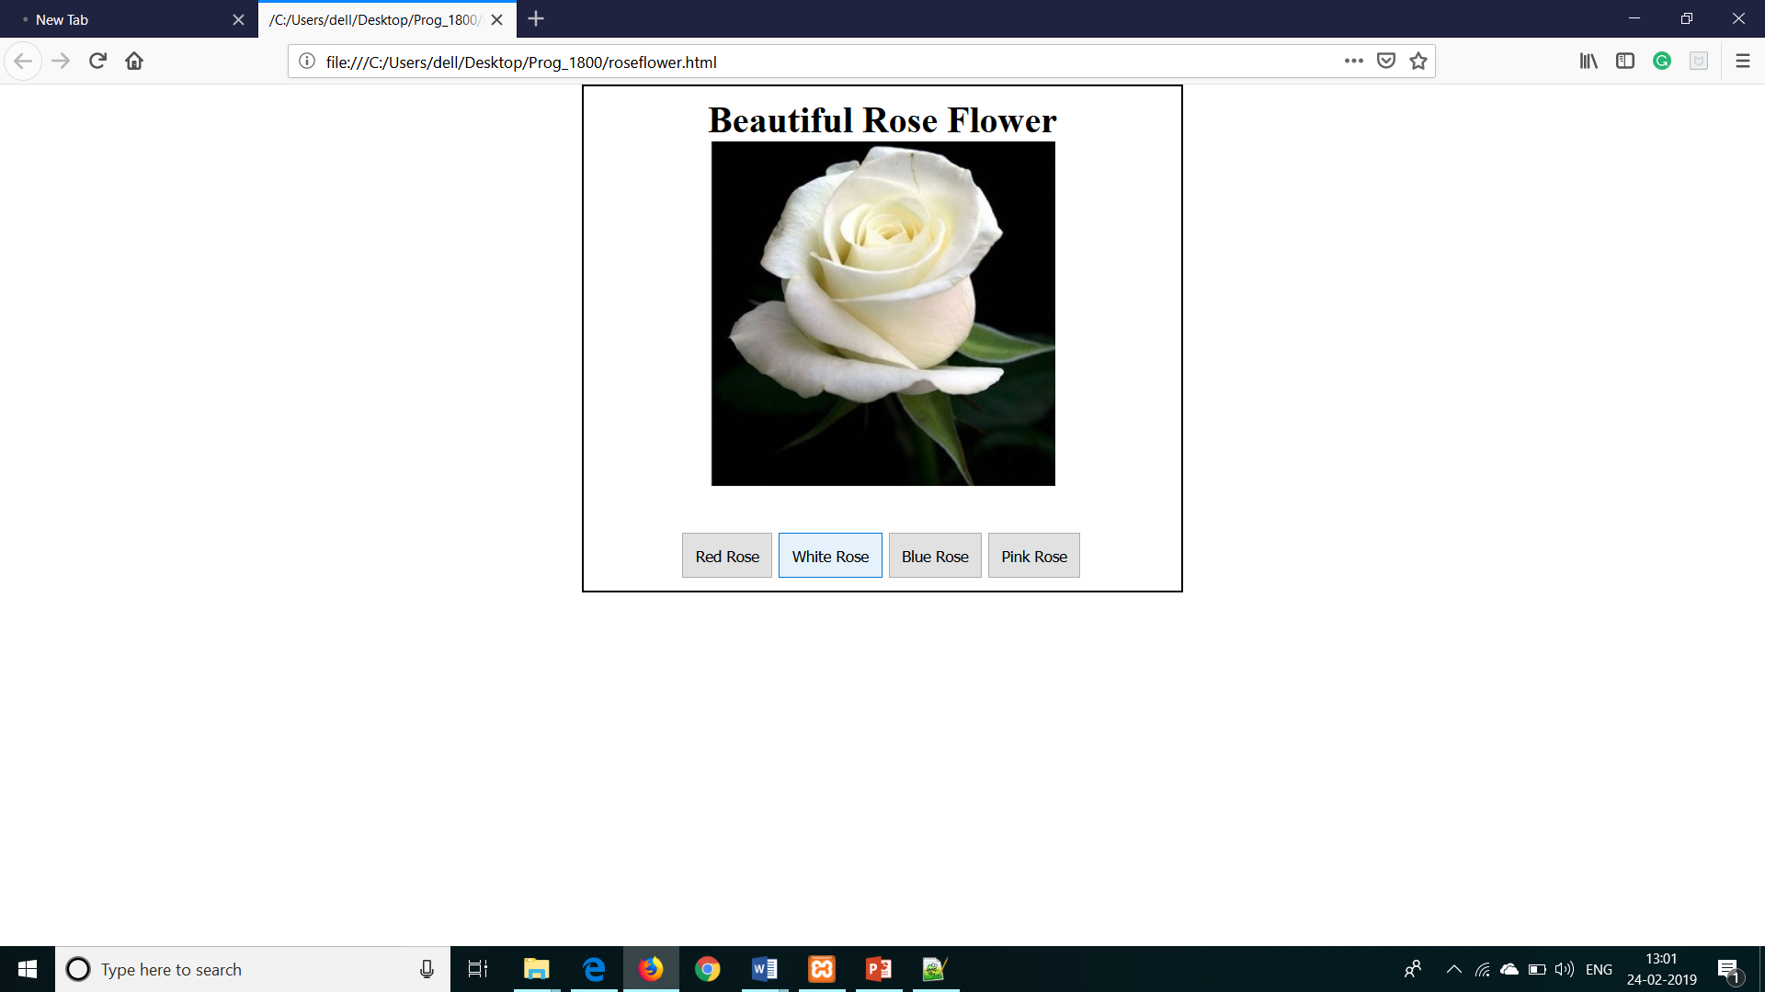 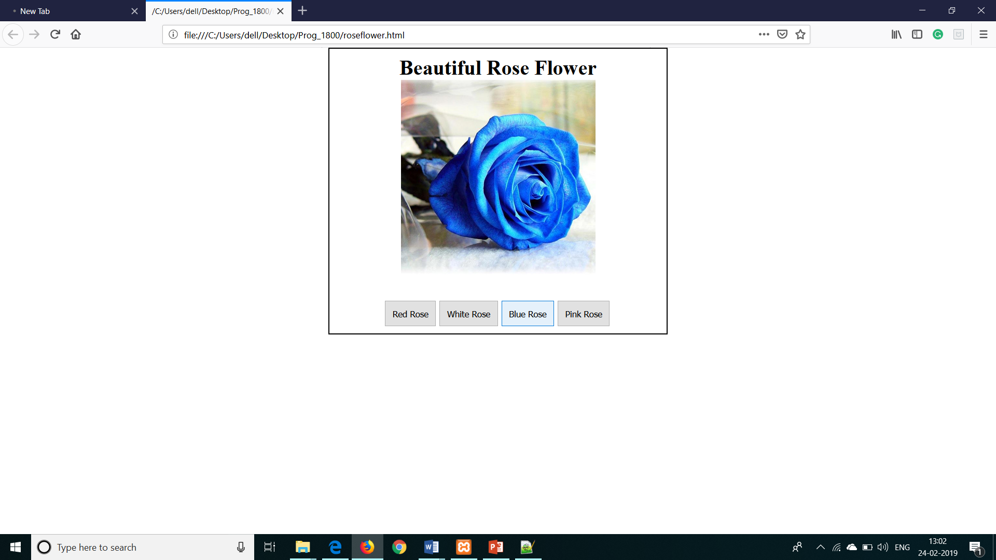

1. Create an application to convert the Fahrenheit to celcius and celcius to Fahrenheit with the help of Javascript. **(5 marks)**

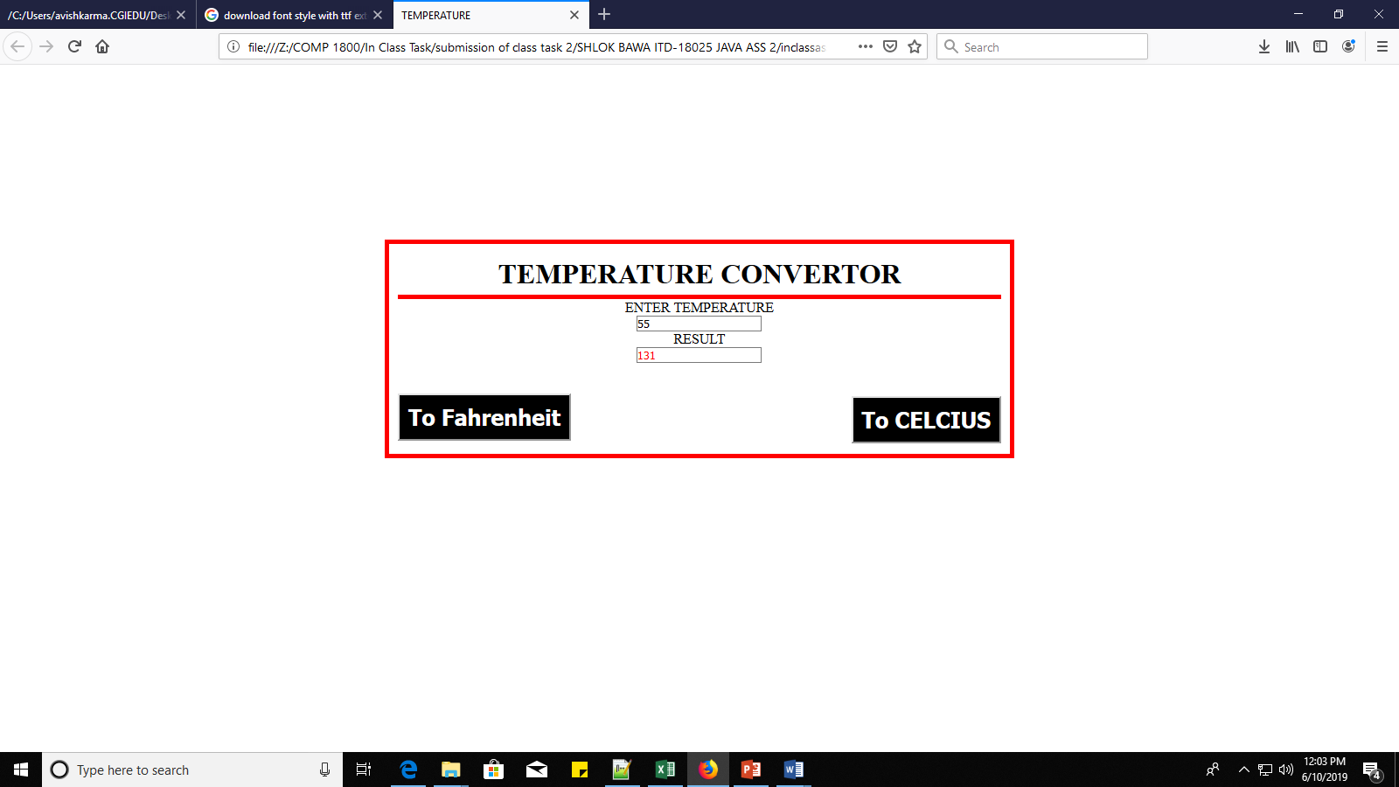

**Formula:F = *C* × 9/5 + 32**